Georgia Fish
Adele Spencer
January 12th, 2016
The Effect of Background Music on Short Term Memory
Introduction
Short-term memory is a temporary recall of information. It is the system used to remember information. (Baddeley, 1998) Our theory is that music distracts us from our work. Some studies have found that music, especially classical, aids in the storage and recall of information in short term memory (Berz, 1995). Different types of music that are more exciting might cause individuals to lose track of their thoughts more easily. A number of important, practical implications found that relatively quiet background sounds will have a marked effect on efficiency in performing cognitive tasks (Banbury, 2001). Our group decided to show that this theory was true by testing if people could remember a list of groceries with and without background music. We decided to research if background music played during memorization of lists varying in length has a significant effect on students' ability to memorize and recall information.

Methods
For our test, we provided a drawing of grocery items on each slide, increasing from four items to eight items, and finally to eleven items. After each slide appeared with the grocery items, a blank screen would appear for 15 seconds, during which the test subject would write down the recalled items in a chart we gave them. After completing three lists with 4,8, and 11 grocery items respectively without background noise, the test subject would repeat the exercise, but with “What Do You Mean” by Justin Bieber playing in the background. We chose to play because it’s a popular, excitement stimulating song and might distract people from remembering their lists when the white screen appears again. We chose an intriguing song because people tend to listen to appealing, popular music while studying or doing homework, however, it may have negative effect on concentration. Our test subjects were primarily between the ages of 13 and 16 but there were also middle-aged which people which provided variation in our test population.
The picture to the right is the text that appears at the bottom of every picture shown.

Figure 1: This slide includes 4 grocery items with their name.
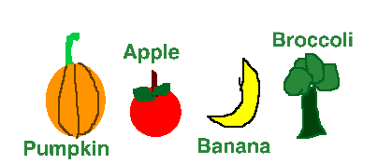
The photo to the left is the first set of grocery items and the first picture shown. Following which a blank screen would enter for 15 seconds and the test subject would write down their list.

Figure 2: This slide includes 8 grocery items with their name.

The photo on the right shows the second list of groceries. Again, a blank screen would appear for 15 seconds in order for the test subject to write down the items.

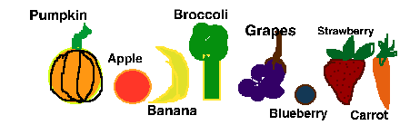

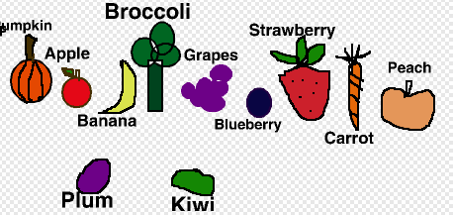
Figure 3: This slide includes 11 grocery items with their name.

The picture to the left is our third and final list, after which a blank screen will appear for 15 seconds in order for the test subject to write down the items.

Results
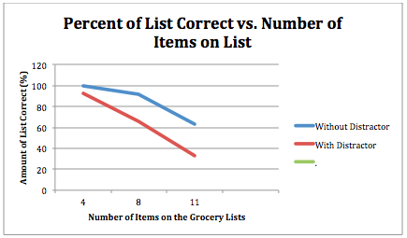
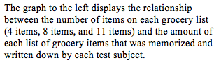
Our experiment tested whether or not playing exciting music would distract you from memorizing lists of 4, 8, and 11 grocery items. We concluded that the music played, “What Do You Mean” by Justin Bieber, does affect your short term memory. Ninety three percent of the test subjects completed the first list of 4 grocery items correctly with and without the distractor. However, when asked to memorise the lists with eight and then eleven items, the majority of the test subjects could only memorise the list without the exciting music.

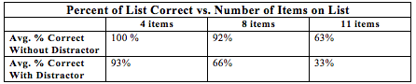
Discussion
The results our experiment presented, that exciting background music has an effect on short-term memory, were the results we expected to get. The P-Values (.0405, .000000165, and .00236) and the chart displaying the percent of test subjects who correctly memorised and wrote down the list of grocery items correctly show that as the lists get longer and the distractor plays, your ability to memorise things using short-term memory decreases drastically.
In conclusion, we determined that playing excitement stimulating music while trying to retain information using short-term memory decreases your ability to focus, comprehend, and write down the new information you learned. The data on our graph shows that the percentage of accuracy went down by 7% when playing the distractor during the list of 4 grocery items, down by 26% when playing the distractor during the list of 8 grocery items, and down by 30% when playing the distractor during the list of 11 grocery items. For further research on our topic, using the scratch program test we made would be a reliable way to collect data. However, a few things you could do that would make the data stronger and more accurate would be monitoring the time of day you give the test subjects the test, testing more than thirty people, and giving the test to a group of test subjects with a large range in age.

Abstract
Short-term memory is a temporary recall of information. Listening to excitement stimulating music has been shown to decrease the amount of information you can recall. Our study investigated if playing “What do You Mean” by Justin Bieber would affect the amount of grocery items you could recall. For our test, we provided a drawing of grocery items on each slide, increasing from four items to eight items, and finally to eleven items with 15 seconds in between for the test subject to write down the grocery items. Each slide played once with no distractor and once with the song playing in the background. From our test, we concluded that as exciting music plays, the amount of information you can recall decreases.

Bibliography
Mastin, L., (2010), Short-Term (Working) Memory, Retrieved from http://www.human-memory.net/types_short.html

Baddeley, A., (2015), Grolier Multimedia Encyclopedia, Retrieved from http://gme.grolier.com/article?assetid=0189950-0

Banbury, SP., Macken, WJ., Tremblay, S., Jones, DM., (2001), Auditory Distraction and Short-Term Memory: Phenomena and Practical Implications, Retrieved from http://www.ncbi.nlm.nih.gov/pubmed/11474757
Denliger, C., (7 Dec. 2012), The Effects of Music (Song) on Short-Term Memory Recall, Retrieved from http://musicandspeech.voices.wooster.edu/.

Matthew, James., (31 Oct. 2011), Background Noise Can Affect Students Test Scores, Retrieved from http://www.earthtimes.org/

Söderlund BW, Göran., Sikström, Sverker., M Loftesnes, Jan., Sonuga-Barke, Edmund J., (2 March 2010), The Effects of Background White Noise on Memory Performance in Inattentive School Children, Retrieved from http://behavioralandbrainfunctions.biomedcentral.com/

Gustavson, Anne., Hanneken, Kevin., Moldysz, Anna., Simon, Brad., (2013), The Effects of Music on Short-Term Memory, Retrieved from http://jass.neuro.wisc.edu/

